CSC500 Module 3: Critical Thinking Assignment

Part 1 – Generate Bill for the Food along with Tip (18%) and Tax (7%) with Input Validation
Pseudocode
BEGIN
IMPORT Decimal and InvalidOperation
START
SET TIP_PERCENT = 0.18
SET TAX_PERCENT = 0.07
SET MIN_AMOUNT = 0.01
SET MAX_AMOUNT = 100000.00
REPEAT
DISPLAY "Enter the charge for the food: "
READ user_input
REMOVE leading and trailing spaces
IF input is empty
DISPLAY "Error: Input cannot be empty."
CONTINUE
TRY convert input to decimal number
IF conversion fails
DISPLAY "Error: Invalid numeric value."
CONTINUE
IF food_charge <= 0
DISPLAY "Error: Amount must be greater than zero."
CONTINUE
IF food_charge < MIN_AMOUNT
DISPLAY "Error: Amount must be at least 0.01."
CONTINUE
IF food_charge > MAX_AMOUNT
DISPLAY "Error: Amount exceeds maximum limit."
CONTINUE
IF more than 2 decimal places
DISPLAY "Error: Only 2 decimal places allowed."
CONTINUE
UNTIL valid input is entered
CALCULATE Total Bill Amount
CALCULATE tip = food_charge × TIP_PERCENT
CALCULATE tax = food_charge × TAX_PERCENT
CALCULATE total = food_charge + tip + tax
DISPLAY food charge
DISPLAY tip amount
DISPLAY tax amount
DISPLAY total amount
END

Source Code
""""
Assignment 3 - Part 1
Restaurant Bill Calculator considering Tip & Tax along with Meal Charge
Author: Shadab
"""
# Python code for Restaurant Bill Calculator
# user provides Inputs at Runtime and also validations
from decimal import Decimal, InvalidOperation
# Define Constants
TIP_PERCENT = Decimal('0.18')
TAX_PERCENT = Decimal('0.07')
MIN_AMOUNT = Decimal('0.50')
MAX_AMOUNT = Decimal('10000.00')
# Function to Input and Validate food charge
def get_food_charge():
while True:
user_input = input('Enter the food charge: ').strip()
#Validations for the input provided
#Empty Input
if user_input == '':
print('Input value cannot be empty!! Please enter a valid food charge.\n')
continue
try:
food_charge = Decimal(user_input)
# Positive Input Value
if food_charge <= 0:
print(f'Invalid Input!! Please enter a valid amount greater than ${MIN_AMOUNT}.\n')
continue
# Minimum Input Value
if food_charge < MIN_AMOUNT:
print(f'Warning!! Amount entered must be at least ${MIN_AMOUNT}.\n')
continue
# Maximum Input Value
if food_charge > MAX_AMOUNT:
print(f'Warning!! Amount entered must be at most ${MAX_AMOUNT}.\n')
continue
# Number of Decimal places in the input value
if food_charge.as_tuple().exponent < -2:
print('Warning!! Please enter the Amount upto 2 decimal places.\n')
continue
return food_charge
except InvalidOperation:
print('Invalid Input!! Please enter only valid numerical amount.\n')
# Function to calculate the bill
def calculate_bill(food_charge):
tip_amount = (food_charge * TIP_PERCENT).quantize(Decimal('0.01'))
tax_amount = (food_charge * TAX_PERCENT).quantize(Decimal('0.01'))
total_bill = (food_charge + tip_amount + tax_amount).quantize(Decimal('0.01'))
return tip_amount, tax_amount, total_bill
# Function to generate the bill
def generate_bill(food_charge, tip_amount, tax_amount, total_bill):
print('\n****** Bill Summary ******\n')
print(f'Food Charge : {food_charge:.2f}')
print(f'Tip Amount (18%): {tip_amount:.2f}')
print(f'Tax Amount (7%) : {tax_amount:.2f}')
print(f'Total Bill : {total_bill:.2f}')
print('\n**************************\n')
def main():
food_charge = get_food_charge()
tip_amount, tax_amount, total_bill = calculate_bill(food_charge)
generate_bill(food_charge, tip_amount, tax_amount, total_bill)
if __name__ == '__main__':
main()

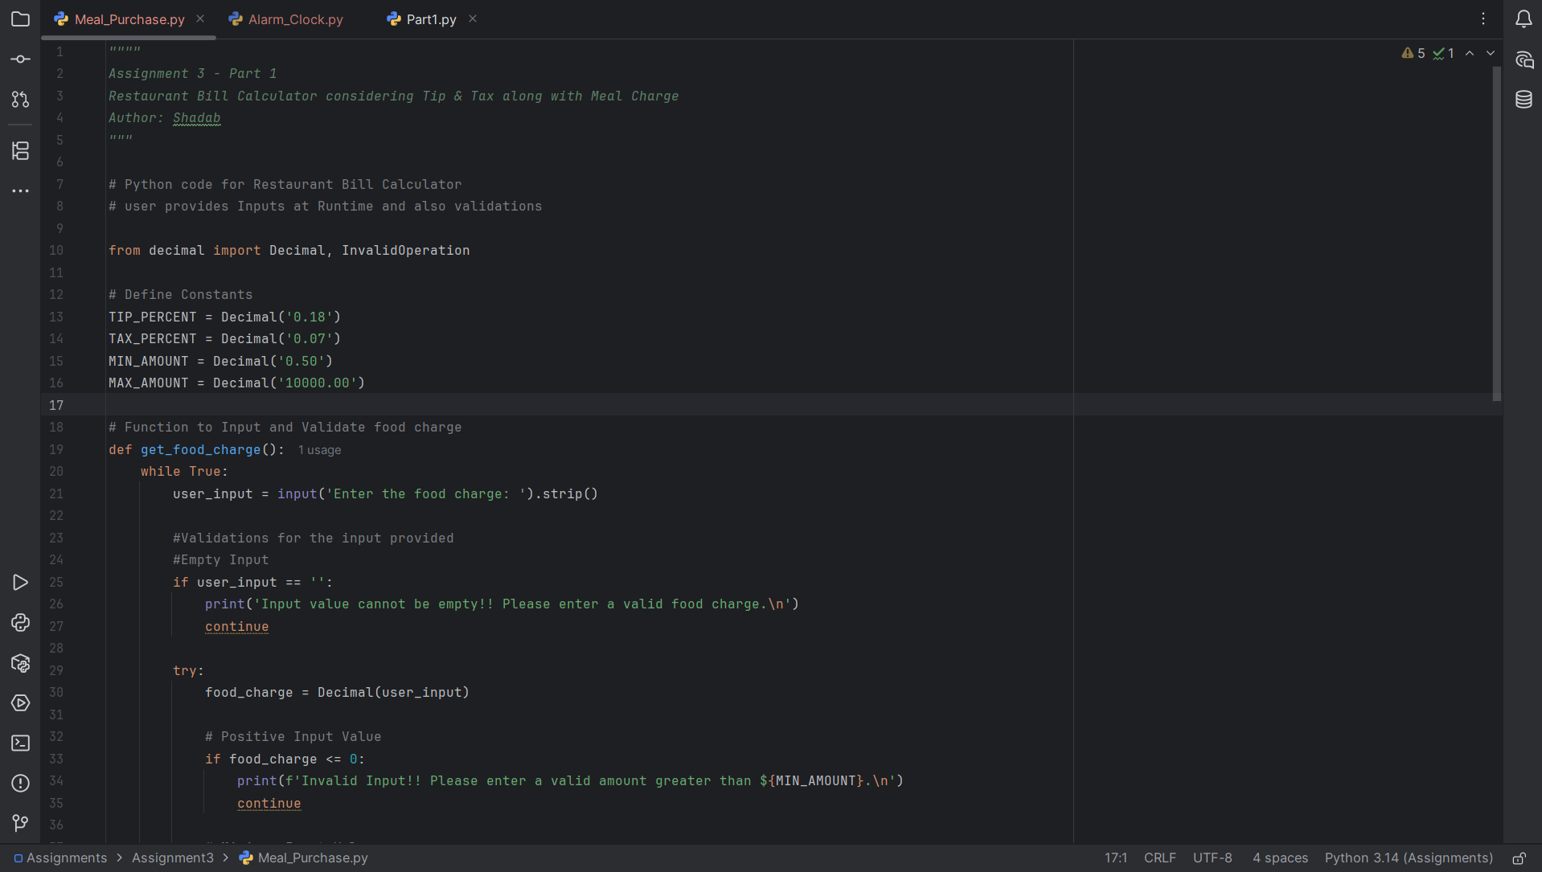

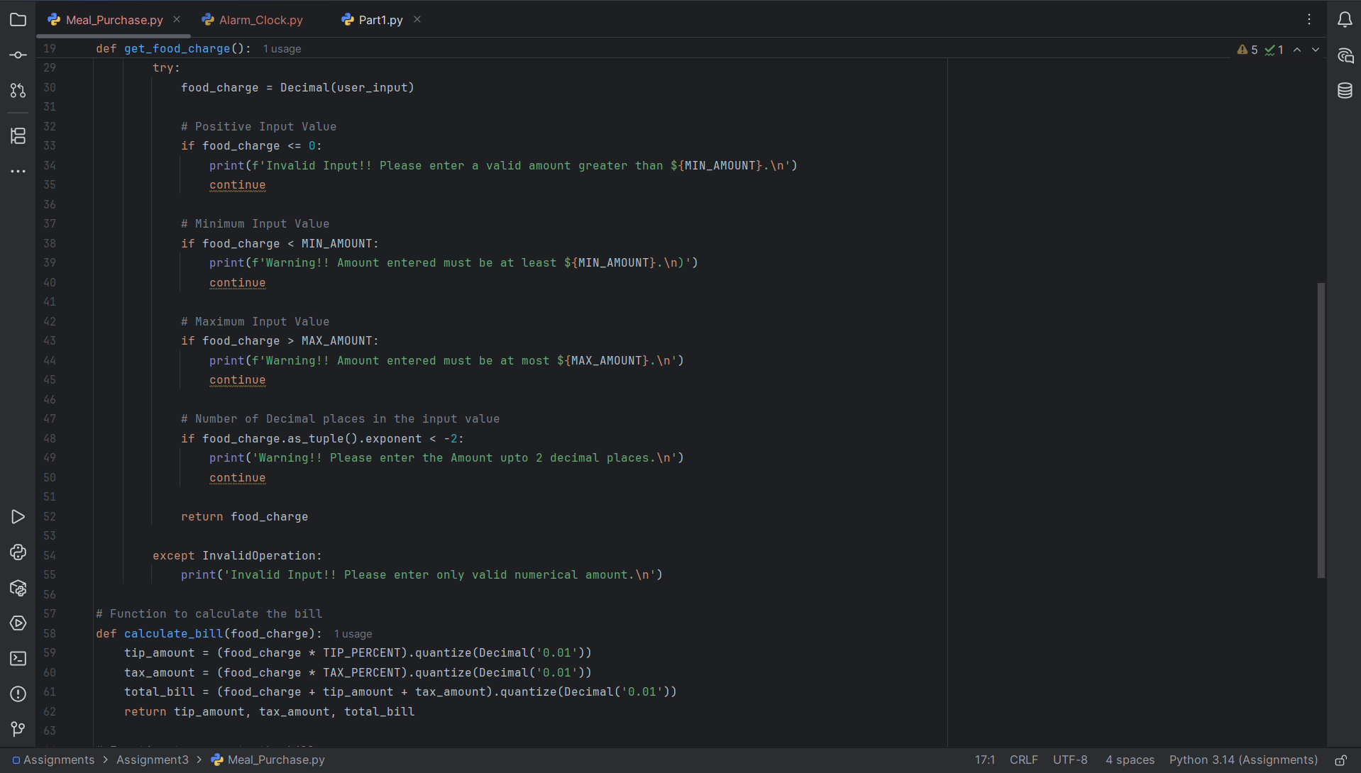

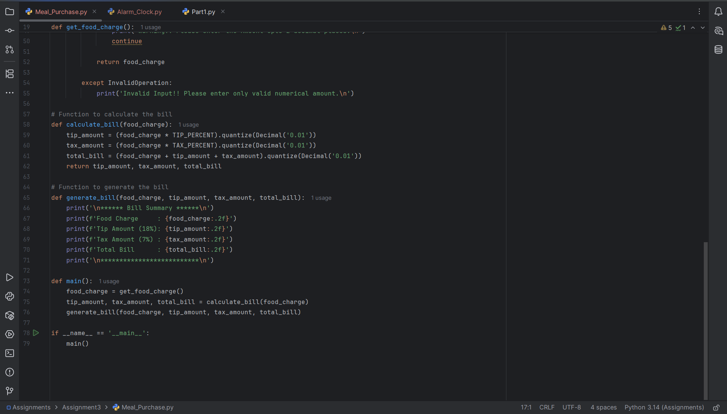

Program Execution Screenshots
Validation 1: When input is empty for food charge
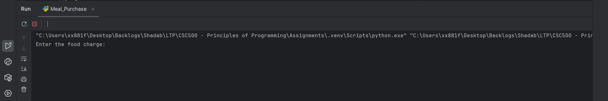

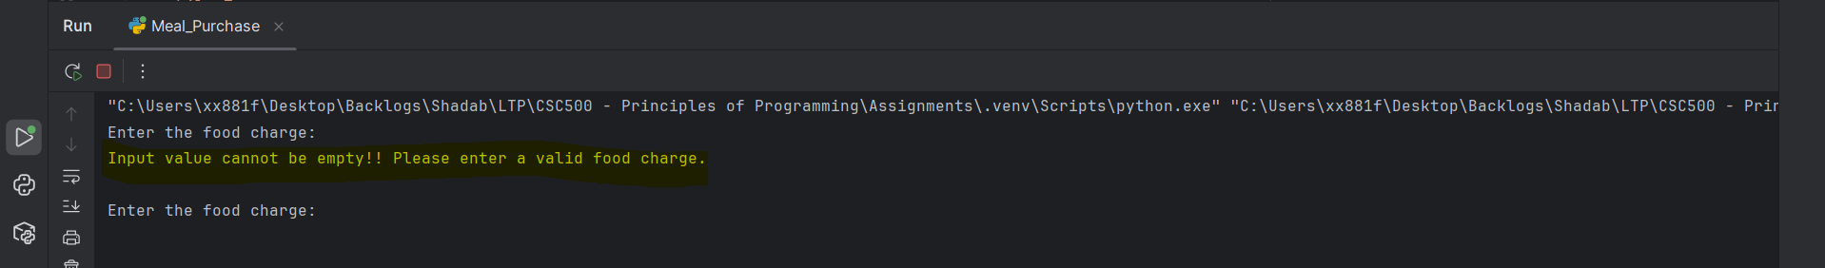

Validation 2: When input provided for food charge is strings
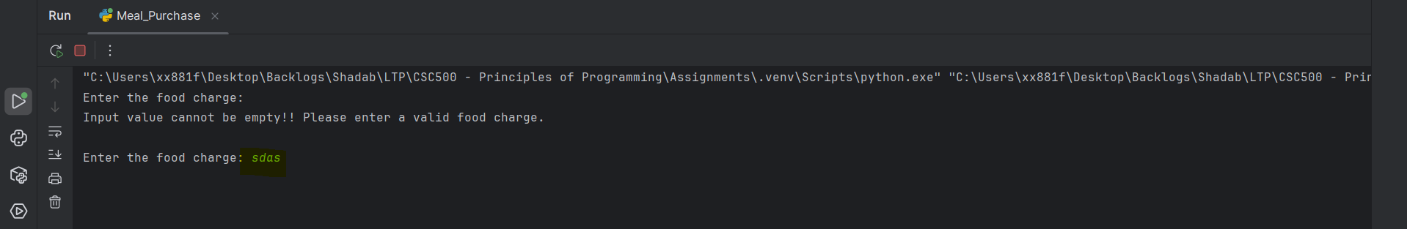

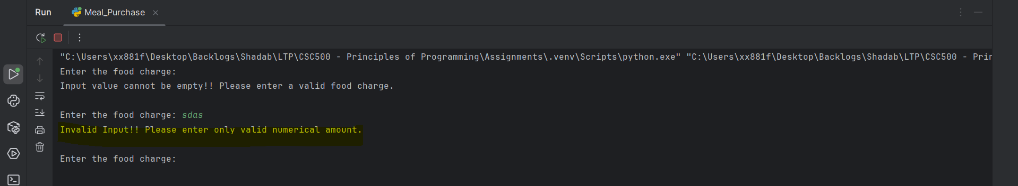

Validation 3: When food charge provided is less than min value and greater than max value set
Min Value = 0.50
Max Value = 10000
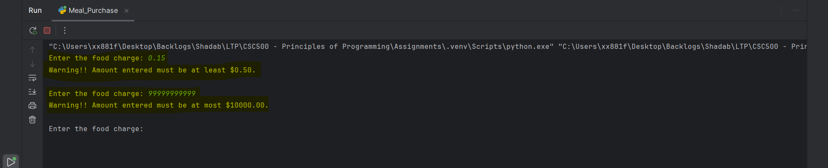

Validation 4: When food charge provided has more than 2 decimals
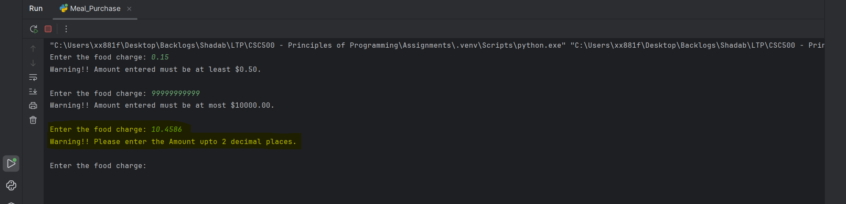

Validation 5: Bill Generation
Food Charge = 100.00
Tip = 18.00
Tax = 7.00
Total bill = 125.00
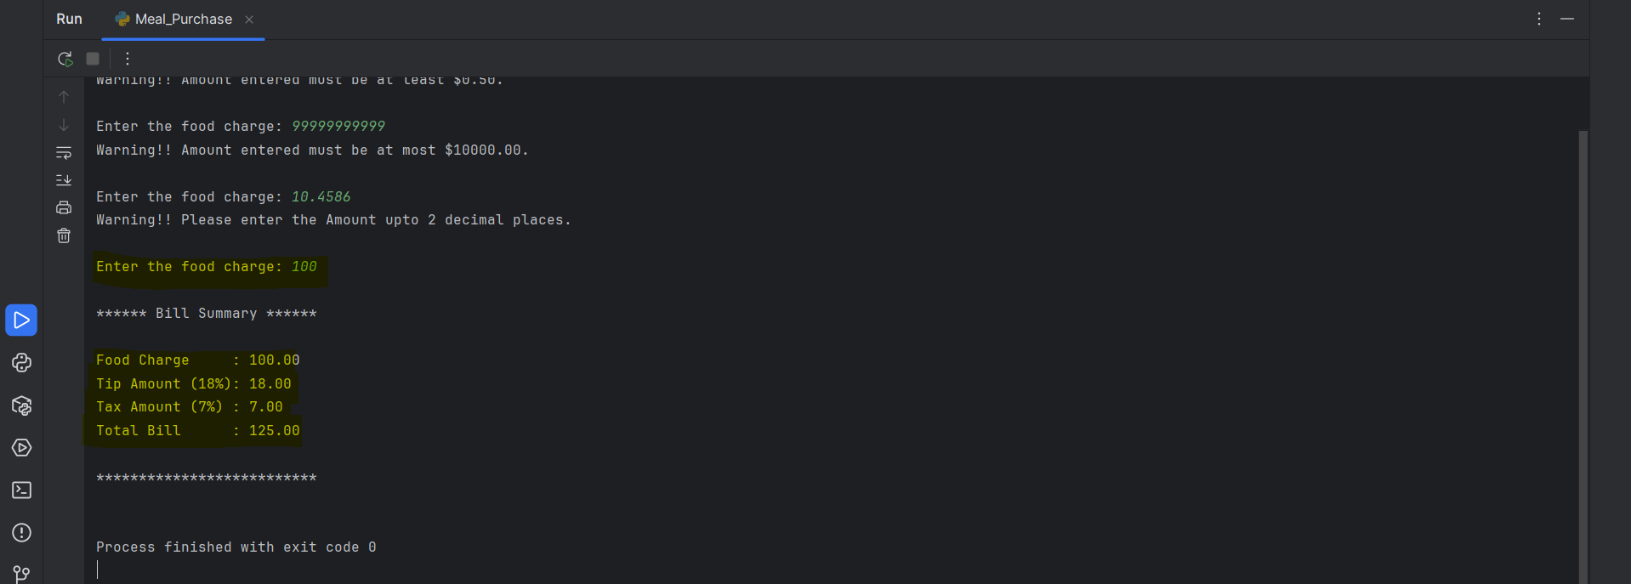

Part 2 - 24-Hour Alarm Clock Program with Input Validation
Pseudocode
START
REPEAT
PROMPT user to enter current time (0-23)
READ user_input
REMOVE leading and trailing spaces
IF input is empty
DISPLAY error message
CONTINUE
TRY convert input to integer
IF conversion fails
DISPLAY error message
CONTINUE
IF current_time < 0 OR current_time > 23
DISPLAY error message
CONTINUE
UNTIL valid current_time is entered
REPEAT
PROMPT user to enter number of hours to wait
READ user_input
REMOVE leading and trailing spaces
IF input is empty
DISPLAY error message
CONTINUE
TRY convert input to integer
IF conversion fails
DISPLAY error message
CONTINUE
IF wait_hours < 0
DISPLAY error message
CONTINUE
UNTIL valid wait_hours is entered
CALCULATE alarm_time = (current_time + wait_hours) MOD 24
CONVERT current_time to 12-hour format
CONVERT alarm_time to 12-hour format
DISPLAY:
Current Time (24-hour format HH:00)
Current Time (12-hour format HH:00 AM/PM)
Wait Time
Alarm Time (24-hour format HH:00)
Alarm Time (12-hour format HH:00 AM/PM)
END

Source Code
""""
Assignment 3 - Part 2
24-Hour Alarm Clock Program
Author: Shadab
"""
# Python code for 24-Hour Alarm Clock Program - With AM/PM Display
# user provides Inputs at Runtime and also validations
#Function to input and Validate Current time
def get_current_time():
while True:
user_input = input('Enter current time (0-23): ').strip()
# Validations for the input provided
# Empty Input
if user_input == '':
print('Input value cannot be empty!! Please enter a valid time.\n')
continue
# Enter value must be integer
try:
current_time = int(user_input)
except ValueError:
print('Warning!! Please enter a valid Integer Value.\n')
continue
# Enter value must be within the range of 0 to 23
if current_time < 0 or current_time > 23:
print('Warning!! Current time must be between 0 and 23.\n')
continue
return current_time
#Function to input and Validate wait hours
def get_wait_time():
while True:
user_input = input('Enter number of hours to wait: ').strip()
# Validations for the input provided
# Empty Input
if user_input == '':
print('Input value cannot be empty!! Please enter a valid number.\n')
continue
# Enter value must be integer
try:
wait_hours = int(user_input)
except ValueError:
print('Warning!! Please enter a valid Integer Value.\n')
continue
# Validation for negative values
if wait_hours < 0:
print('Invalid Input!! Hours to wait cannot be negative.\n')
continue
return wait_hours
# Function to calculate alarm time
def calculate_alarm_time(current_time, wait_hours):
return (current_time + wait_hours) % 24
# Function to conver 24-hour to 12-hour format
def convert_to_12_hour_format(hour):
if hour == 0:
return 12, 'AM'
elif 1 <= hour < 12:
return hour, 'AM'
elif hour == 12:
return 12, 'PM'
else:
return hour - 12, 'PM'
def main():
current_time = get_current_time()
wait_hours = get_wait_time()
alarm_time = calculate_alarm_time(current_time, wait_hours)
current_12_format, current_period = convert_to_12_hour_format(current_time)
alarm_12_format, alarm_period = convert_to_12_hour_format(alarm_time)
hour_label = 'hr' if wait_hours == 1 else 'hrs'
print("\n************ Alarm Summary ************\n")
print(f'Current Time (24-hour) : {current_time:02d}:00\n')
print(f'Current Time (12-hour) : {current_12_format:02d}:00 {current_period}\n')
print(f'Wait Time (in hours) : {wait_hours} {hour_label}\n')
print(f'Alarm Time (24-hour) : {alarm_time:02d}:00\n')
print(f'Alarm Time (12-hour) : {alarm_12_format:02d}:00 {alarm_period}\n')
print("\n**************************************\n")
if __name__ == '__main__':
main()
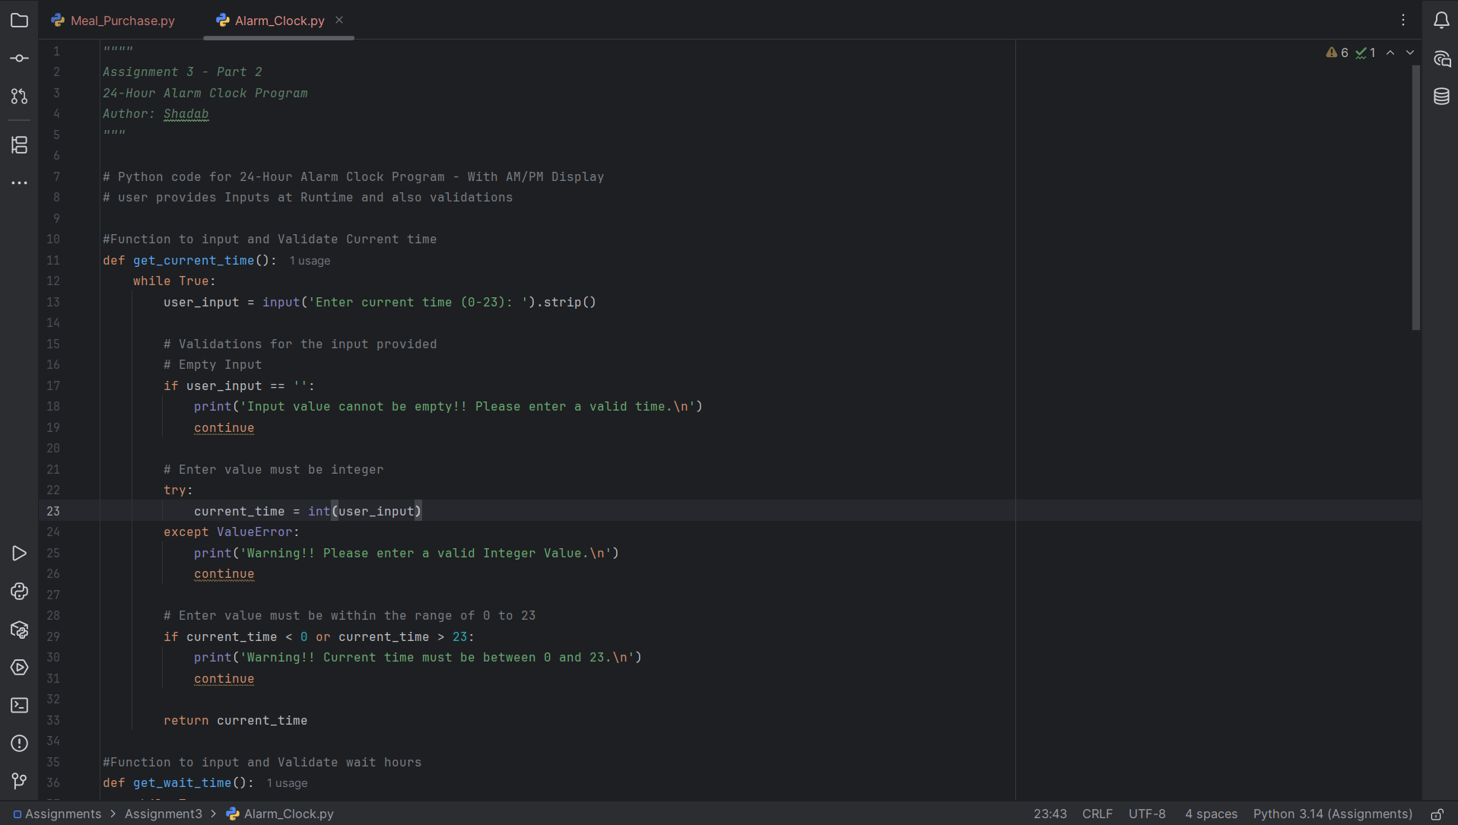

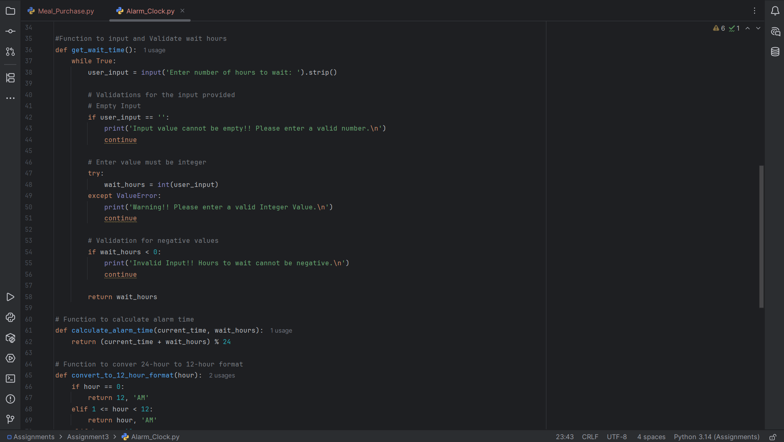

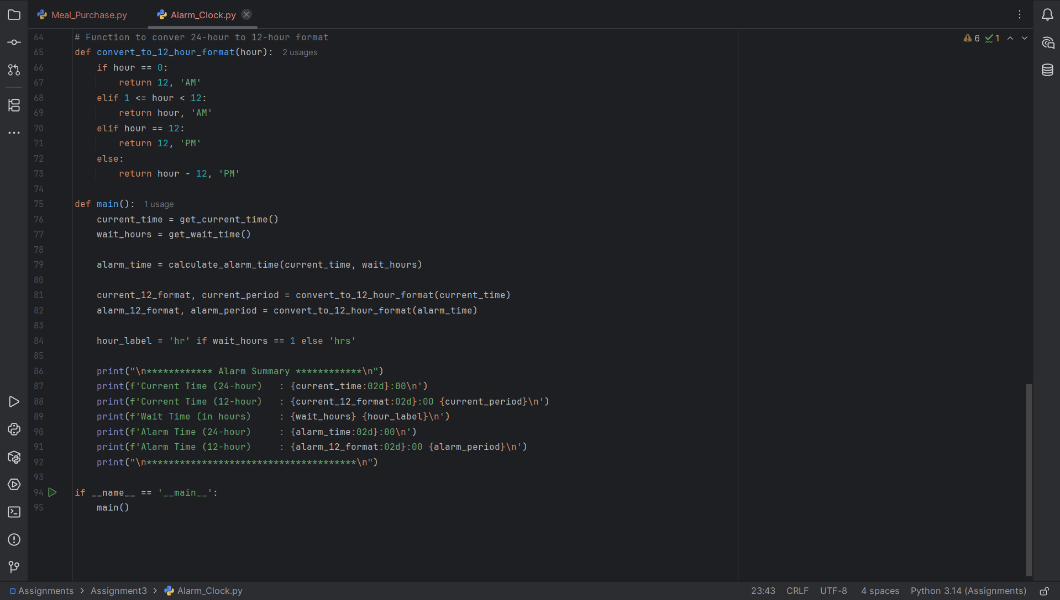

Program Execution Screenshots

Validation 1: When current time input is empty
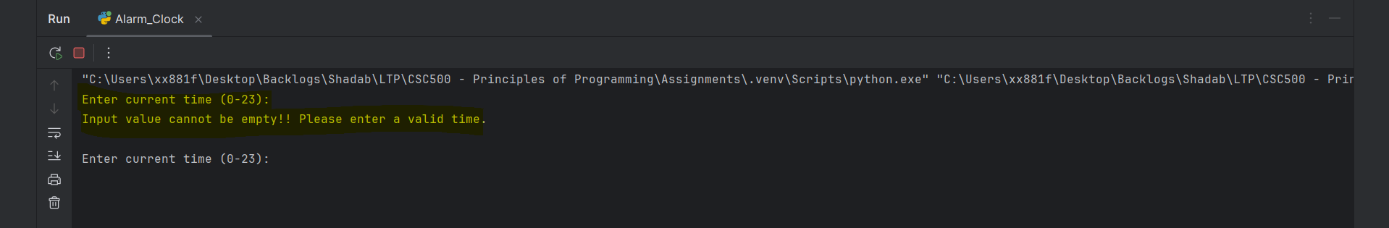

Validation 2: When current time input is strings
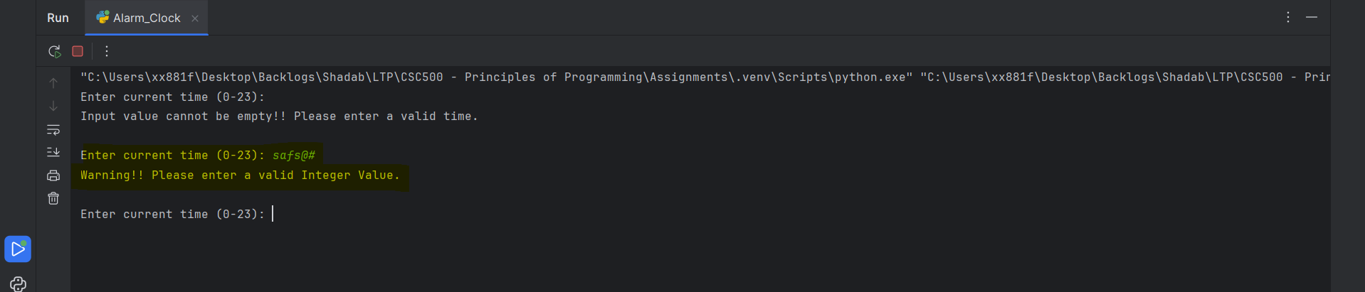

Validation 3: When current time input value must be within the range of 0 to 23
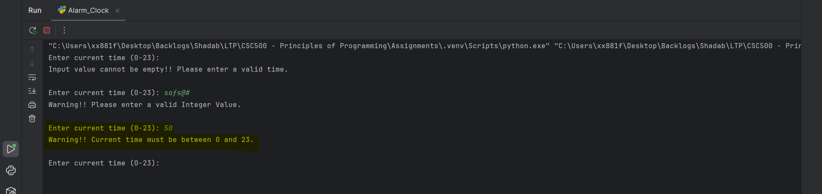

Validation 4: When number of hours to wait input is empty
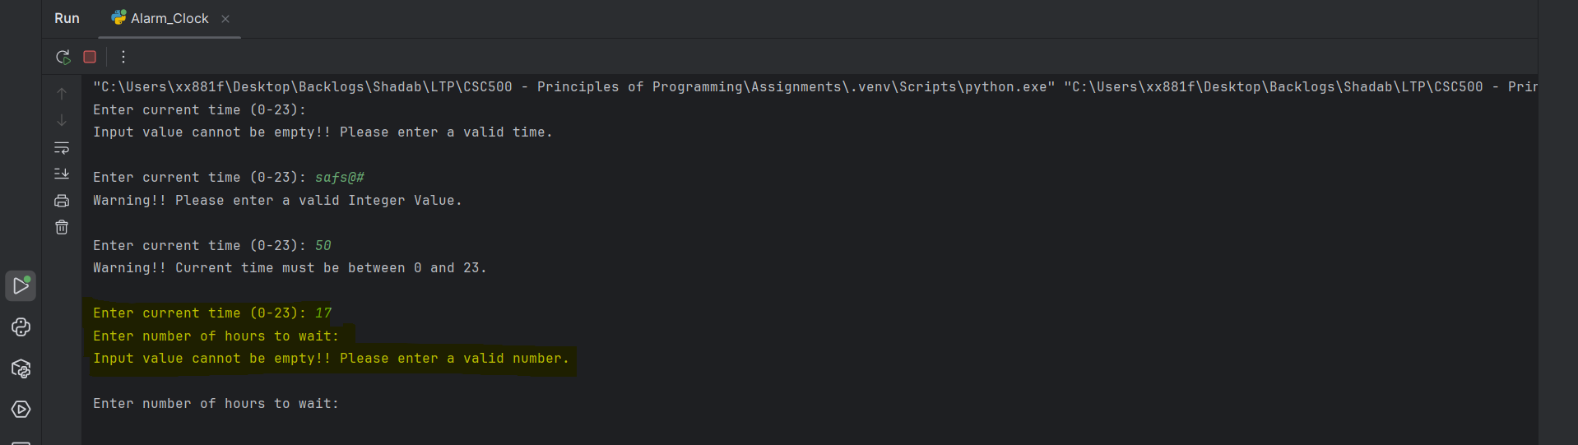

Validation 5: When number of hours to wait input is strings
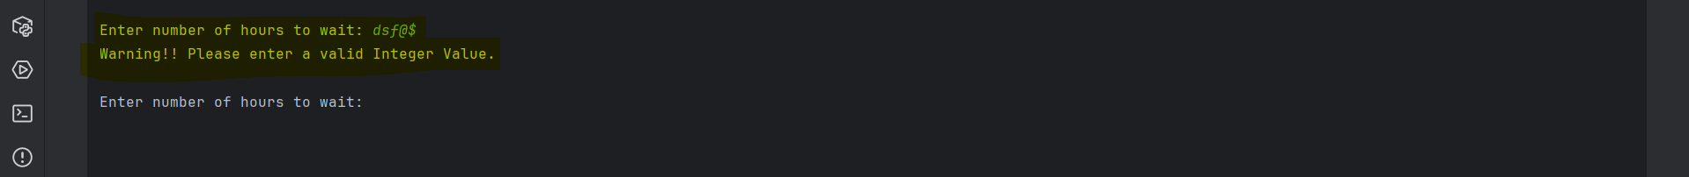

Validation 6: When number of hours to wait input is negative
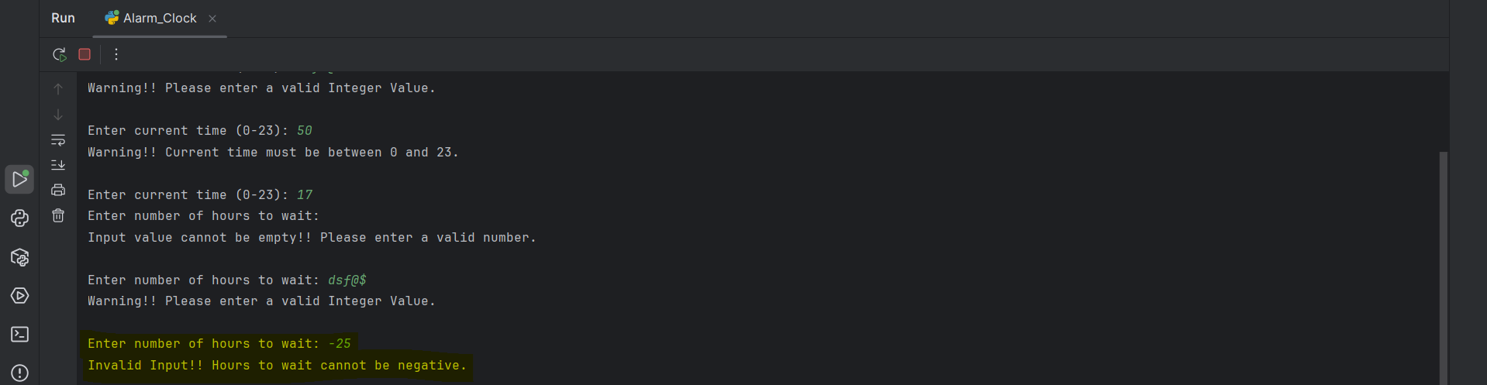

Validation 7: When number of hours to wait input has decimal values
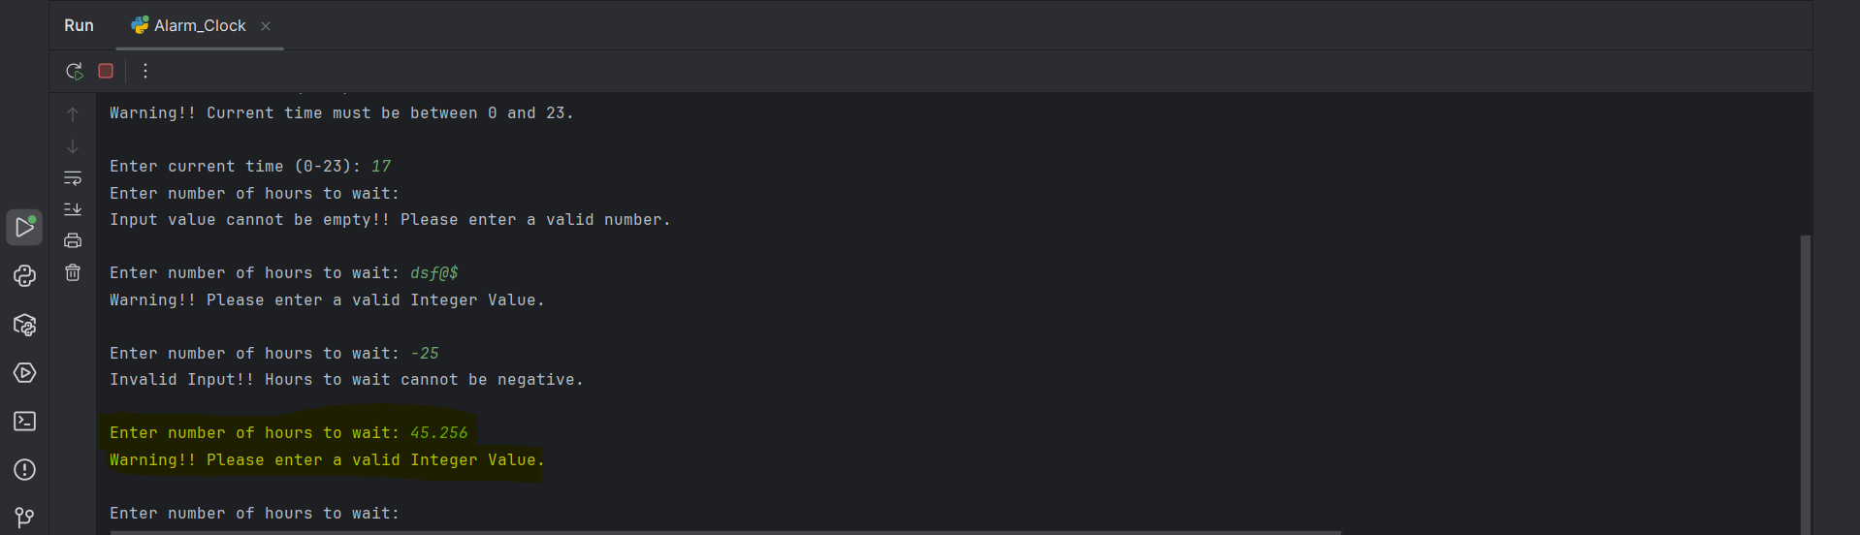
Validation 8: Calculating Alarm Time
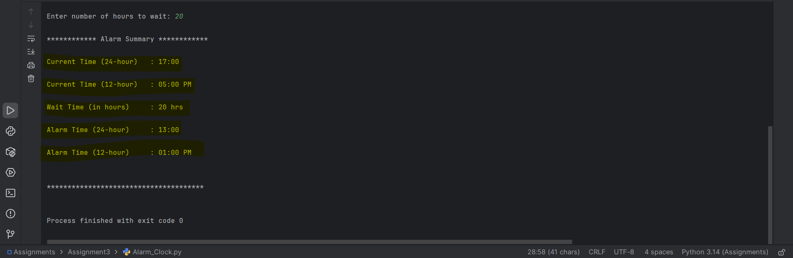

Part 3 – Git Repository
Created a Git-Hub Account with Repository name as “CSC500---Principles-of-Programming”
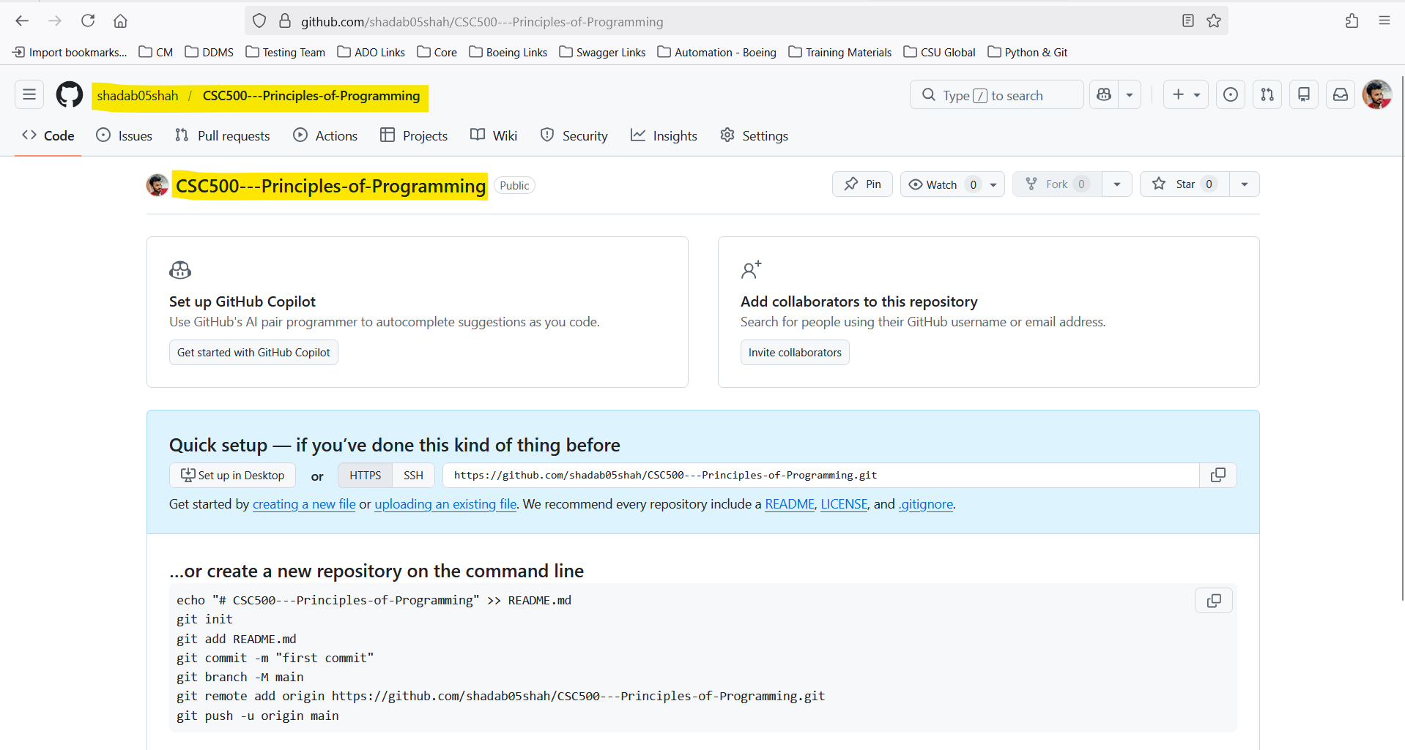

Main Project Folder Structure in Local

Initialize Git using “git init”
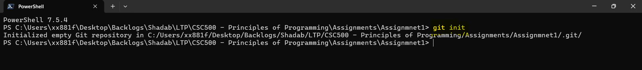

Add Files using “git add .”
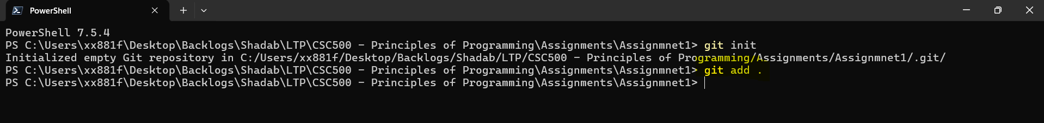

Commit Files using “git commit -m “Added assignment for part1 and part2””
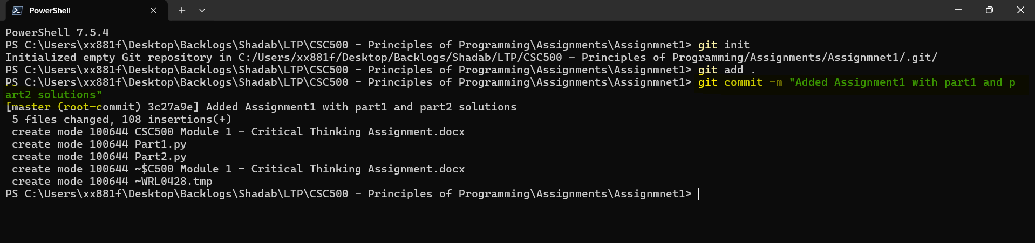

Connecting to Git-Hub using the repository link created in browser “git remote add origin https://github.com/shadab05shah/CSC500---Principles-of-Programming.git”
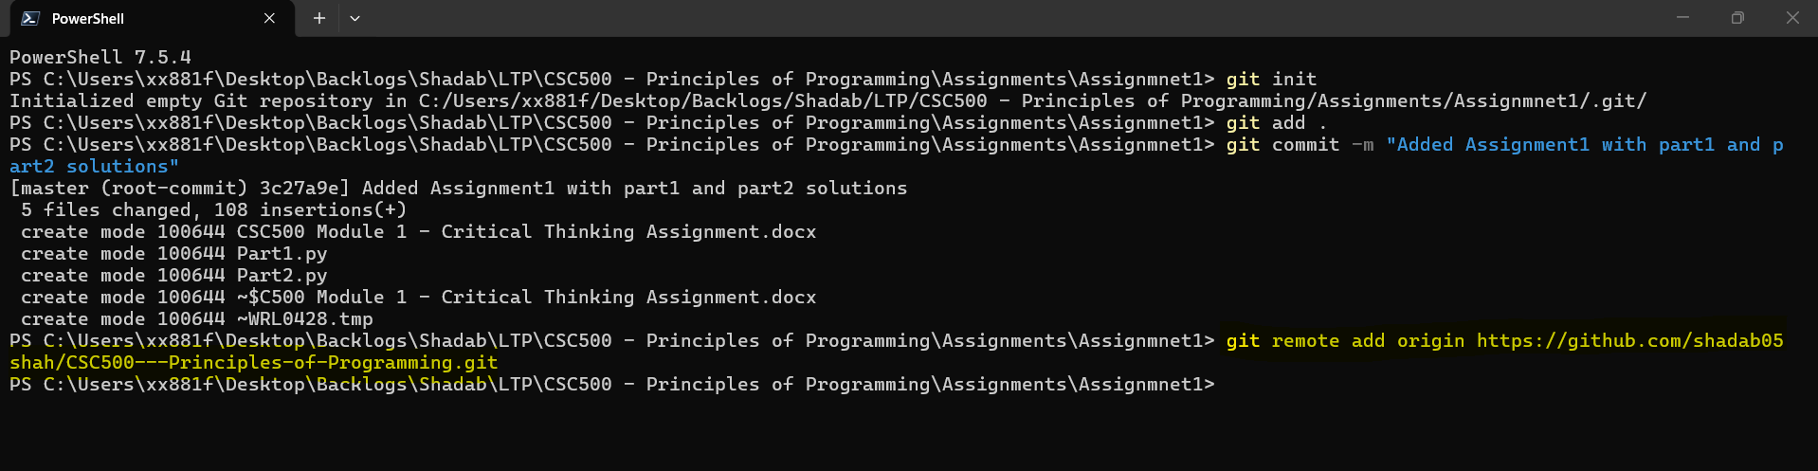

Pushing Changes to Github using
Git branch -M main
Git push -u origin main
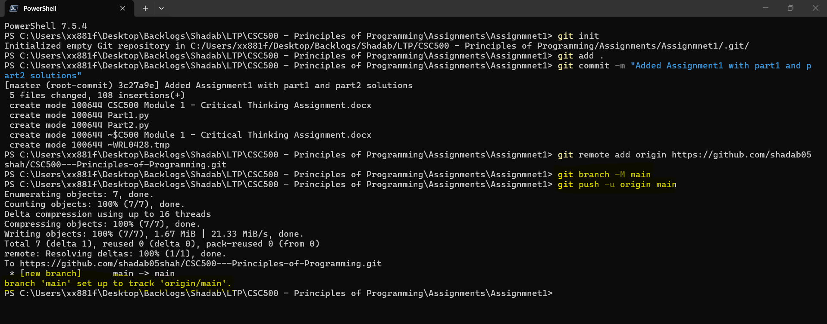

In Git-Hub repo page
